Date: September 18, 2025

Ref:

REQUEST FOR TENDERS

SUPPLY OF TRANSPORTATION SERVICES FOR BREGADO FLAX EDUCATIONAL CENTRE SECONDARY STUDENTS: NORTH SOUND TO THE BREGADO FLAX EDUCATIONAL CENTRE

PART A – GENERAL PROVISIONS

- Introduction

  - The Government of the Virgin Islands (GoVI or the “Purchaser”) acting through the Ministry of Education, Youth Affairs & Sports (MEYAS) invites tenders for the Supply of Transportation Services for Bregado Flax Educational Centre Secondary Students: North Sound to the Bregado Flax Educational Centre, located at Valley, Virgin Gorda, British Virgin Islands (hereinafter referred to as the “Services”).

  - Tenders are sought on a competitive basis and all prices are subjected to detailed scrutiny. The tender, as well as all correspondences and documents relating to the tender between the Tenderer and GOVI, shall be in the English language. Supporting documents and printed literature provided by the Tenderer may be in another language but they must be accompanied by an accurate translation of the relevant passages in the English language, in which case, for the purposes of interpretation of the tender, the translation shall govern.

  - GOVI, therefore, invites eligible tenderers to respond to this Request for Tender (RFT) and submit tenders for the Supply of Transportation Services for Bregado Flax Educational Centre Secondary Students: North Sound to the Bregado Flax Educational Centre.

  - The Services are intended to provide subsidized transportation costs to parents of students attending the Bregado Flax Educational Centre Secondary, living more than walking distance from the school.

  - As a part of this procurement process, you are required to visit the site in good time to allow you to assess the existing conditions, the requirements of the Services, and determine the equipment, materials, and labour required to complete the Services. (If necessary)
  - Section 5 of this Request for Tenders (RFT) provides the general requirements for the Services from which a tender should be prepared.

- Submission of Tenders

  - The Tenderer should read these instructions carefully before completing the tender documentation. The Tender must include each of the following documents identified below, fully completed by the Tenderer together with any supporting literature required by the relevant document. The documents marked ‘Appendix’ are provided as appendices to this document.

• Form of Tender (Appendix A)
- Tender Price (Appendix B)
- Experience in the supply and delivery of similar goods or works over the past 3 years
• Valid Trade License related to the provision of the required goods
• Certificate of Good Standing from the Commercial Registry and a Certificate of Incorporation (if a registered company)
• Proof that the company or individual is in good standing with respect to taxes, duties, social security and national health insurance contributions, company registration, or payments due to the Government of the Virgin Islands. Certificates of Good Standing must be obtained from the Director of Social Security Board and National Health Insurance, and the Commissioner of Inland Revenue

  - Failure to comply with any of the instructions concerning completion and submission of these documents may render (at GoVI’s absolute discretion) the Tender non-compliant.

  - The Form of Contract, if required, is attached at Appendix D. It identifies the proposed terms and conditions, and the documents that shall be incorporated within any resulting Contract.

  - Tenders must be submitted to the Permanent Secretary, Ministry of Education, Youth Affairs & Sports at the following address:

Permanent Secretary
Ministry of Education, Youth Affairs & Sports
2nd Floor E.A Creque Building
Main Street
Road Town, Tortola
BRITISH VIRGIN ISLANDS

  - Tenderers must submit one (1) original copy and one (1) additional copy of the complete tender package, including appendices and supporting literature in one envelope clearly marked with the reference “Supply of Transportation Services for Bregado Flax Educational Centre Secondary Students: North Sound to the Bregado Flax Educational Centre”. The original tender and copy must be clearly marked accordingly, and all information must be legible.

  - Tenders must be submitted no later than 7th October, 2025 at 10:00am local time. Tenders received after this date and time will be rejected and not be considered.

- Site Visit

  - Tenderers are required to visit the site to assess the existing conditions, the requirements of the Services, and determine the equipment and labour required to complete the Services. (If necessary)

- General

  - GoVI reserves the right, and at its own discretion, to accept or reject any Tender, and to annul the process and reject all Tenders, at any time prior to award of contract without assigning reason, and without incurring any liability to the affected prospective Tenderer(s).

  - GOVI will not defray any costs incurred by any Tenderer in the preparation of Tenders.

PART B – EMPLOYER’S REQUIREMENTS

- Tender Specifications

  - The successful tenderer (the “Contractor”) will be required to Supply Transportation Service from North Sound, Virgin Gorda to the Bregado Flax Educational Centre to satisfy the following requirements:

    - The vehicle(s) to be used in the performance of this agreement has (have) been duly registered and licensed for the purpose described in Clause 1 hereof.

    - The driver(s) is (are) properly licensed to drive the particular type of vehicle in public passenger transport service.

    - The vehicle(s) to be used has (have) been adequately insured against third party risks by presenting for inspection of the documents listed in the second schedule hereto.

    - Provide information of the health and safety of their vehicle(s) by stating how often the vehicle is cleaned and maintained for transporting students.

    - Rate would be based on child per month.

    - Proof that company/individual is in good standing with respect to taxes, duties, social security and national health insurance contributions, company registration (Trade License), or payments due to the Government of the Virgin Islands. These certificates of good standing can be obtained from the Director of Social Security Board and National Health Insurance, the Commissioner of Inland Revenue and Company Registry.

    - All services to be performed to the satisfaction of the Principal or Chief Education Officer in the Ministry of Education, Youth Affairs and Sports.

- Time of Engagement

  - The duration of this engagement will be for a period of one (1) year (October 2025 to June 2026).

- Evaluation

  - Price, experience, and submission of Good Standing Certificate(s) are the factors that will be considered in this evaluation. Therefore, the tenderer attaining the highest evaluation score will be selected as the recommended tenderer and invited to negotiate a contract to supply the Services.

- Disclaimers

  - The Tender process is governed by and construed in accordance with the Laws of the Virgin Islands.

  - All material issued in connection with this RFT shall remain the property of GOVI and shall be used only for the purpose of this competitive tendering exercise.

  - GOVI shall not be committed to any course of action as a result of:

    - Issuing an RFT;

    - Communicating with a Tenderer or a Tenderer’s representatives or agents in respect of this procurement; or

    - Any other communication between GOVI and any other party.

  - Tenderers shall accept and acknowledge that by issuing this RFT, GOVI shall not be bound to accept any Tender and reserves the right not to award the Contract for some or all of the Works for which Tenders are invited.

  - No information contained in this RFT, or in any communication made between GOVI and any Tenderer in connection with this RFT, shall be relied upon as constituting a Contract, agreement, or representation that any Contract shall be offered as a result of this competitive tendering exercise. GOVI reserves the right, to change without notice the basis of, or the procedures for, the competitive tendering exercise or to terminate the competitive tendering exercise at any time.

  - Tenderers are solely responsible for the costs and expenses incurred in connection with the preparation and submission of their Tender and all other stages of the selection and evaluation process. Under no circumstances will GOVI or any of their advisers, be liable for any costs or expenses borne by Tenderers, sub-contractors, suppliers, or advisers in this competitive tendering exercise.

  - GOVI reserves the right to reject Tenders which are not submitted in accordance with the instructions given, including but not limited to where a Tenderer:

    - Submits it Tender after the deadline for tender submissions;

    - Provides a Tender that is incomplete and fails to provide any of the required information;

  - GOVI reserves the right to reject any or all Tenders, to stop the competitive tendering exercise and not award the Contract (in whole or in part) at any time without any liability on its part. Nothing in this competitive tendering exercise is intended to form any express or implied contractual relationship between the parties unless and until the Contract is executed by both parties.

  - Where there is any indication that a conflict of interest exists or may arise then it shall be the responsibility of the Tenderer to inform GOVI detailing the conflict in writing. GOVI will be a final arbiter on cases of potential conflicts of interest. A failure to notify GOVI of any potential conflict of interest will invalidate any oral or written agreement.

  - Participation in the tendering process shall be treated by GOVI as acceptance by the Tenderer of all the terms and conditions contained in this RFT (or any other statement that may be issued by GOVI to Tenderers from time to time) relating to the conduct of this competitive tendering exercise (including any subsequent award of a Contract).

  - Tenderers must be explicit and comprehensive in their responses to this RFT as this will be the single source of information on which responses will be evaluated save for any further information or advice sought by GOVI in accordance with the Clarification of Tenders paragraph above. Tenderers are advised neither to make any assumptions about their past or current supplier/contractor relationships with GOVI nor to assume that such prior business relationships will be taken into account in the evaluation procedure.

  - The RFT is issued on the basis that nothing contained in it shall constitute an inducement or incentive nor shall have in any other way persuaded a Tenderer to submit a Tender or enter into the Contract or any other contractual agreement.

  - GOVI relies on a Tenderer's own analysis and review of information provided. Consequently, Tenderers are solely responsible for obtaining the information which they consider is necessary in order to make decisions regarding the content of their Tenders and to undertake any investigations they consider necessary in order to verify any information provided to them during the competitive tendering exercise.

- Corrupt and Fraudulent Practices

  - GOVI requires that Tenderers, Suppliers, Contractors, and Consultants under GOVI-funded contracts, observe the highest standard of ethics during the procurement and execution of such contracts. In pursuit of this policy, GOVI:

9.1.1. Defines, for the purposes of this provision, the terms set forth below as follows:

      - “Corrupt practice” means the offering, giving, receiving, or soliciting, directly or indirectly, of anything of value to influence the action of a public official in the procurement process or in contract execution.

      - “Fraudulent practice” means a misrepresentation of facts in order to influence a procurement process or the execution of a contract.

      - “Collusive practice” means a scheme or arrangement between two or more Tenderers, with or without the knowledge of the Recipient, designed to establish Tender prices at artificial, non-competitive levels; and

      - “Coercive practice” means harming or threatening to harm, directly or indirectly, persons or their property to influence their participation in the procurement process or affect the execution of a contract.

    - Will reject a proposal for award if it determines that the Tenderer recommended for award has, directly or through an agent, engaged in corrupt, fraudulent, collusive or coercive practices in competing for the Contract; and

    - May sanction a firm or individual, including declaring them ineligible, either indefinitely or for a stated period of time, to be awarded a GOVI-financed contract if it at any time determines that they have, directly or through an agent, engage in corrupt, fraudulent, collusive, or coercive practices in competing for, or in executing, a GOVI-financed contract.

- Tender Validity

  - Tenders should remain open for acceptance for a period of 30 days from date of the Tender closing date.

End of Section

APPENDIX A

FORM OF TENDER

Permanent Secretary
Ministry of Education, Youth Affairs & Sports
2nd Floor, E.A. Creque Building
Main Street
Road Town, Tortola
British Virgin Islands

TENDER

For: Supply of Transportation Services of Bregado Flax Educational Centre Secondary Students: North Sound to the Bregado Flax Educational Centre

To: Permanent Secretary, Ministry of Education, Youth Affairs & Sports

1. Based upon the requirements of this Request for Tender, the undersigned proposes to complete the Services as indicated in our tender submission and in accordance with the Tender Documents for the sum of (US$),

US$__________________________________________________ (amount in figures)

__________________________________________________________________________

_______________________________________________________ (amount in words)

payable by the Government of the Virgin Islands.

2. The undersigned engagement will be for the period of October 2025 to June 2026.

3. We agree that the proper law of the Contract shall be the Laws of the Virgin Islands.

4. We agree that these tender documents shall comprise the sole binding documentation applicable to this tender or to the contract.

5. We agree that all information supplied by the Employer to the Tenderer will be treated in confidence and not disclosed to third parties except insofar as this is necessary to obtain sureties or tenders for the purpose of submitting the tender. All information supplied by the Tenderer to the Employer will similarly be treated in confidence, except, that references may be sought from banks, existing or past clients, or other referees submitted by the Tenderer.

6. We accept full responsibility for the accuracy of all prices provided in this tender and agree that these prices include full provision for any increases in the costs for whatsoever reason over the period of time from submission of tender to completion of the project and settlement of the final account.

7. We accept that any and all omissions or errors in pricing are our responsibility and agree that should any errors in arithmetic be discovered in the Tender submitted by us during consideration of this offer, these errors will be corrected by giving us an opportunity of either confirming our offer or amending it to correct such errors.

- If this offer is accepted and subject to and in accordance with paragraphs 2, 3, 4, 5, 6 and 7 above and the terms and conditions contained referred to in the Tender Documents, we undertake to provide the required services as in accordance with the contract.

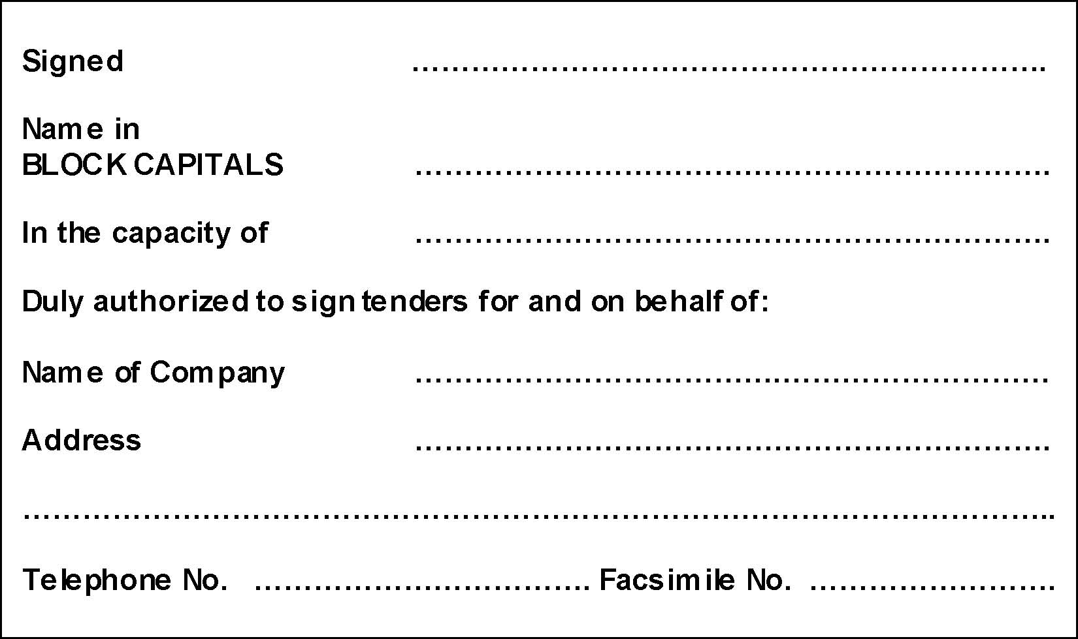

APPENDIX B

TENDER PRICE

Item | Description | Rate per child per month
1 | Fee for the Supply of Transportation Services for Bregado Flax Educational Centre Secondary Students from North Sound to the Bregado Flax Educational Centre in the Valley, Virgin Gorda for the period October 2025 to June 2026 in accordance with Section 5 of the RFT for 2025.

