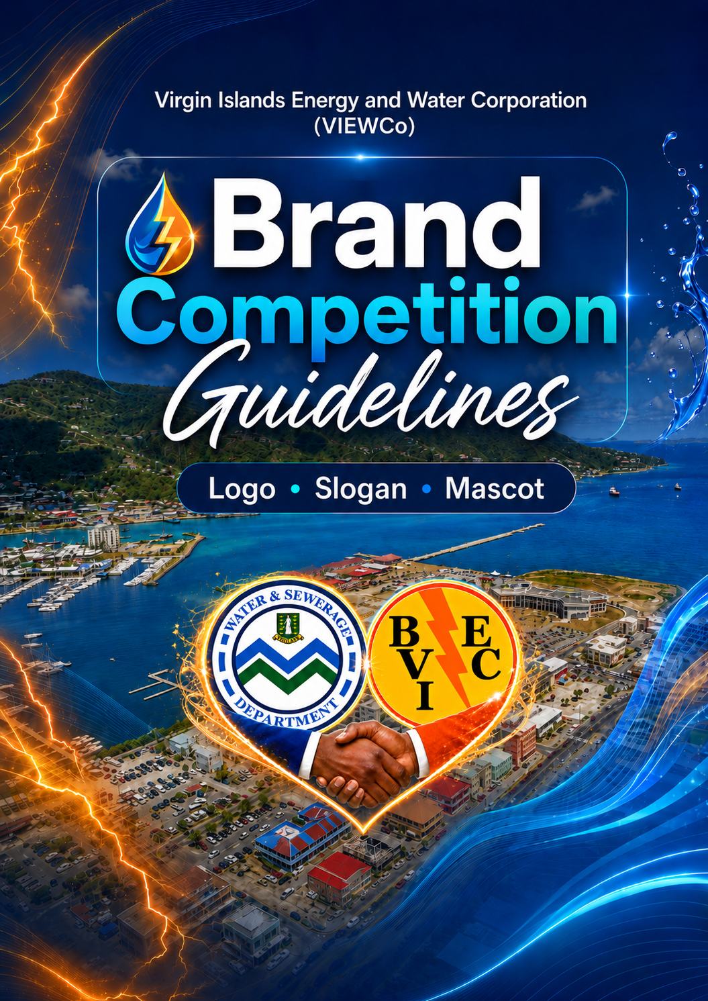

1. Background
The Government of the Virgin Islands invites persons currently residing in the Territory, including students at the primary, secondary and tertiary levels, to participate in three historic competitions to design the official logo, slogan, and mascot for the newly established Virgin Islands Energy and Water Corporation (VIEWCo).
The Virgin Islands Energy and Water Corporation is the statutory body formed through the merger of the BVI Electricity Corporation (BVIEC) and the Water and Sewerage Department (WSD), which unites the delivery of electricity, water, and sewerage services under one organisation dedicated to providing reliable, sustainable, and innovative utility services for the people of the Virgin Islands.
The winning designs will become the official corporate identity of VIEWCo. They will be used on uniforms, vehicles, buildings, customer communications, utility infrastructure, safety equipment, signage, digital platforms, and official publications.

2. Overview
As a newly established organisation, VIEWCo requires a strong, distinctive and unified corporate identity that represents the integration of energy, water and sewerage services under one entity.
To encourage public ownership and participation in the formation of the new corporation, VIEWCo is launching three national brand competitions:
- VIEWCo Logo Competition
- VIEWCo Slogan Competition
- VIEWCo Mascot Competition
Each competition operates as a standalone initiative with its own framework, guidelines, and timeline. All three share common principles: submissions must reflect VIEWCo’s mission to deliver reliable, modern and sustainable energy, water and sewerage services to the people of the Virgin Islands, and must represent the integration of both legacy organisations into one unified corporation.

2.1 VIEWCo Vision, Mission and Core Values
All submissions across all three competitions must clearly reflect the Visions, Missions, and Core Values of both legacy organisations (BVIEC & WSD).
BVI Electricity Corporation
VISION
To be a Centre of Excellence in the production and distribution of Reliable, Affordable, and clean energy.
MISSION
We are committed to delivering an exceptional customer experience by fostering partnerships and safely developing the BVI as we invest in our people and provide sustainable, innovative energy solutions at an affordable cost.
CORE VALUES
Integrity, Accountability, Customer Focus, Respect, Transparency, Reliability, Safety, Unity, Innovation and Results-Oriented.

Water and Sewerage Department
VISION
The Water and Sewerage Department is a customer-oriented government department that facilitates the delivery of quality and affordable water supply and sewage disposal services to all residents of the Virgin Islands.
MISSION
We seek to ensure the provision of a continuous supply of safe, potable water and an environmentally sound sewage disposal service to all residents of the Virgin Islands, efficiently and at affordable rates.

3. Common Provisions – All Competitions

3.1 Eligibility
- Open to persons currently residing in the British Virgin Islands
- Employees of BVIEC and the Water and Sewerage Department are eligible to participate
- Students from all levels (primary, secondary & tertiary) are eligible to participate
- Entrants under the age of 18 must have parental or guardian consent
- Only one entry per person is permitted

3.2 Intellectual Property
- All successful competition submissions become the intellectual property of VIEWCo once a decision of the winner is made
- Each entrant is required to sign an IP Assignment Declaration as part of the submission process, confirming that their work is original and that all rights transfer to the corporation upon winning the respective competition
- VIEWCo reserves the right to modify, adapt, or further develop any winning submission for corporate use
- Submissions must not infringe on any existing copyright, trademark, or intellectual property of any third party

3.3 Submission Requirements
- All entries must be submitted digitally via email to: mcw@gov.vg
- The email subject line must clearly state the competition name (e.g. “VIEWCo Logo Competition”, “VIEWCo Slogan Competition”, or “VIEWCo Mascot Competition”)
- Where file sizes are large, participants may submit via a download link (Google Drive, Dropbox, or similar)
- Submissions must be free of watermarks, signatures, or identifying marks on the design itself
- Each submission must be accompanied by a completed entry form (available on the Government website)
- All entries must be original and non-plagiarised

3.4 Judging Process
- During judging, all entrant names are omitted; submissions are assessed using assigned contestant numbers
- A Selection Panel comprising 7 members, including:
  - A member from Department of Information and Public Relations (GIS),
  - A BVIEC Board representative
  - One member each from BVIEC & WSD Senior Management
  - BVIEC PR & Marketing Manager
  - A representative from the Ministry of Communications and Works
  - An independent professional graphic artist.
- Prescreening to be conducted to remove unacceptable submissions
  - At least two members of the Selection Panel are to execute this process
- The Selection Panel then votes on the shortlisted finalists
- The top three (3) finalists are subject to a staff voting component
- The Panel submits a recommendation to the Ministry of Communications and Works
- Final selection authority rests with the Ministry
- The decision of the Ministry is final and not subject to appeal by competitors

3.5 Prize Structure
Each competition carries the following prize:
Competition | Prize
VIEWCo Logo Competition | $2,500
VIEWCo Slogan Competition | $1,000
VIEWCo Mascot Competition | $1,000

4. VIEWCo Approved Colour Palette
The following colour palette has been established for the VIEWCo brand identity. It incorporates heritage colours from both legacy organisations (BVIEC and the Water and Sewerage Department) while introducing green to represent VIEWCo’s commitment to renewable energy and environmental sustainability.
Logo Competition entrants are encouraged to use the approved colour palette as a guide; however, this is not mandatory. Entrants are welcome to exercise creative freedom in selecting colours that best support their design concept. This flexibility also applies to Slogan and Mascot Competition entrants, where relevant.

4.1 Primary Palette
Colour Name | Hex Code | RGB | Represents
VIEWCo Navy | #1B3A5C | R:27 G:58 B:92 | Strength, stability, trust (heritage: BVIEC)
Ocean Blue | #0077B6 | R:0 G:119 B:182 | Water services, clarity, the sea (heritage: Water and Sewerage)
Leaf Green | #00A523 | R:0 G:165 B:35 | Growth, renewal, sustainability, safety, freshness, and progress
VIEWCo White | #FFFFFF | R:255 G:255 B:255 | Clean water, transparency, clarity

4.2 Secondary Palette
Colour Name | Hex Code | RGB | Represents
Vivid Orange | #F46C1D | R:244 G:108 B:29 | Energy, warmth, electricity (heritage: BVIEC)
Golden Yellow | #F8D62F | R:248 G:214 B:47 | Sunlight, solar energy, optimism (heritage: BVIEC)
Deep Teal | #006D6F | R:0 G:109 B:111 | Integration of water and energy, Caribbean identity
Neutral Grey | #6B7B8D | R:107 G:123 B:141 | Professionalism, infrastructure, modernity
Black | #000000 | R:0 G:0 B:0 | Standard for words or letters
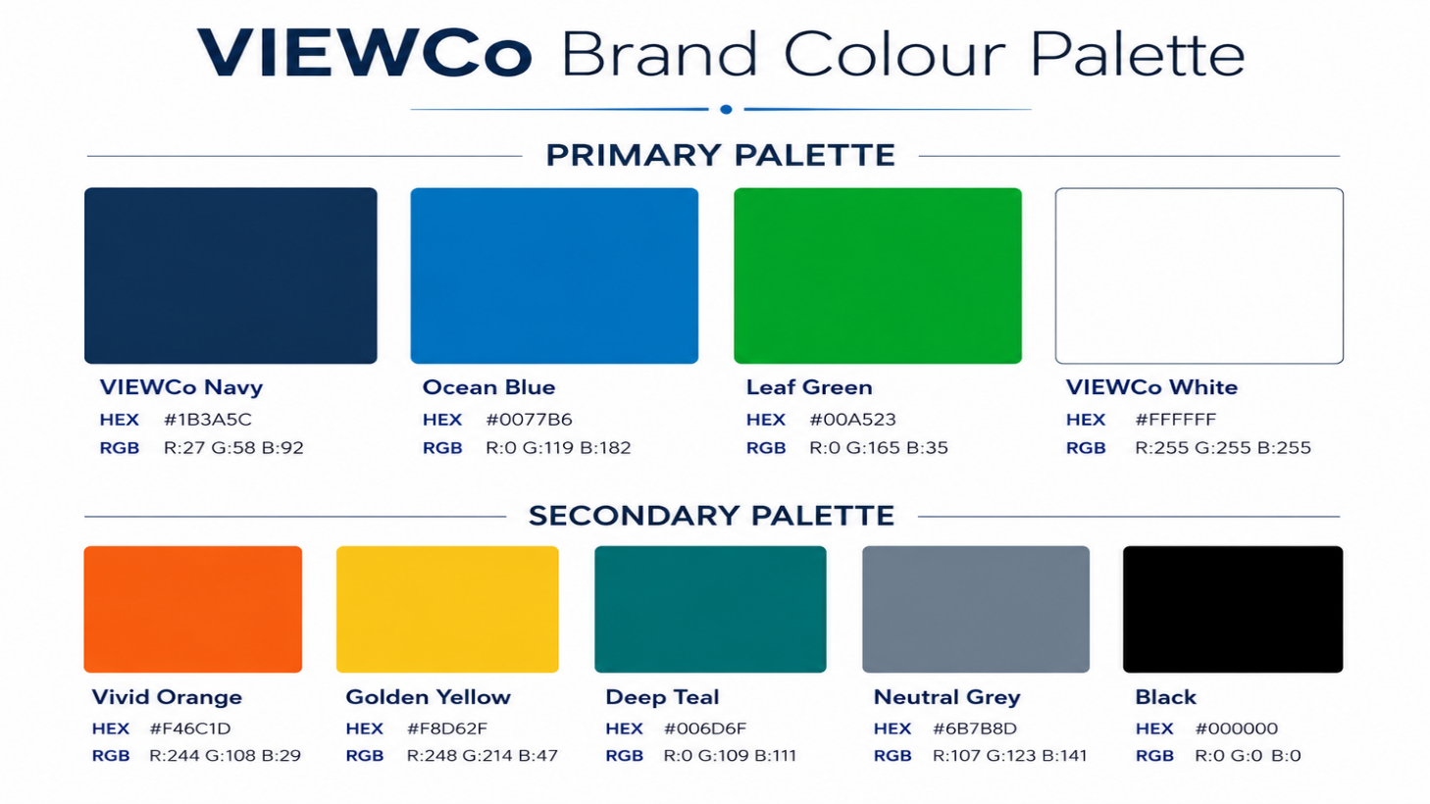

5. VIEWCo Logo Competition Guidelines
The VIEWCo Logo Competition invites persons currently residing in the British Virgin Islands to design the official logo for the new corporation. The winning logo becomes the primary visual identity of VIEWCo and is applied across all corporate materials, facilities, vehicles, digital platforms, and public communications.

5.1 Design Brief
The VIEWCo logo must:
- Visually represent the integration of energy (electricity) and water and sewerage services into one unified corporation
- Reflect the Vision, Mission, and Core Values of BVIEC and WSD
- Communicate modernity, reliability, sustainability, and service to the people of the Virgin Islands
- Be distinctive, memorable, and recognisable at all sizes
- Function effectively across all environments: from building signage to social media profile icons
- Avoid clichés (e.g. generic light bulbs, water drops, or power plugs) unless integrated into a sophisticated and original concept

5.2 Colour Requirements
Logo submissions can consist of colours from VIEWCo’s colour palette defined in Section 4, but are not limited to the colours listed.
- The primary palette (VIEWCo Navy, Ocean Blue, Leaf Green, White)
- Secondary palette colours (Vivid Orange, Golden Yellow, Deep Teal, Neutral Grey)
- Submissions must demonstrate that the logo works in full colour, single colour (black on white, white on dark background), and greyscale

5.3 Dynamic Logo Requirements
The VIEWCo logo must be designed as a dynamic identity system, capable of adapting its appearance to reflect different contexts and service divisions while maintaining a consistent core structure. This is a critical requirement.
Entrants must submit their logo in the following configurations:

Configuration | Description | Colour Suggestion
Primary Logo (Default) | The standard VIEWCo corporate logo used on all general materials, letterheads, signage, and corporate communications | Balanced representation of energy and water
Electricity Division Variant | A colour-shifted version of the same logo structure emphasising the energy/electricity identity | VIEWCo Navy, Vivid Orange, Golden Yellow as dominant
Water and Sewerage Division Variant | A colour-shifted version of the same logo structure emphasising water services | Ocean Blue, Deep Teal, White as dominant
Renewable Energy / Sustainability Variant | A colour-shifted version used for renewable energy communications, sustainability campaigns, and environmental messaging | Leaf Green, Golden Yellow, White as dominant
Single Colour (Dark) | The logo rendered in a single dark colour for use on light backgrounds, monochrome printing, and engraving | Black (#000000) or VIEWCo Navy (#1B3A5C)
Single Colour (Light / Reversed) | The logo rendered in white for use on dark backgrounds, branded merchandise, and vehicle livery | White (#FFFFFF)

The core logo structure (icon, wordmark, and composition) must remain consistent across all variants. Only the colour treatment changes. Entrants should consider how the logo’s graphic elements naturally lend themselves to colour variation across the service divisions.

5.4 Technical Specifications
All logo submissions must meet the following technical standards:

Requirement | Specification
File Format (required) | Scalable Vector Graphics (SVG), Adobe Illustrator (AI) or Encapsulated PostScript (EPS) format. The logo must be in true vector format, not a rasterised image embedded in a vector file
File Format (supplementary) | High-resolution PNG (minimum 3000 x 3000 pixels, transparent background) for each variant
Vector Quality | All paths must be clean, properly closed, and free of unnecessary anchor points. No embedded raster images, no auto-traced artwork
Scalability | The logo must reproduce clearly at a minimum size of 25mm wide (for print) and 80 pixels wide (for digital) without loss of legibility or detail
Clear Space | Entrants should indicate a recommended minimum clear space (protective space) around the logo
Colour Mode | Vector files in CMYK colour mode. PNG files in RGB colour mode. Hex codes for all colours must be documented
Typography | All text in the logo must be converted to outlines/paths in vector files

5.5 Submission Guidelines
Each Logo Competition entry must include:
- The primary (default) logo in vector format (SVG, AI [Adobe Illustrator], or EPS)
- All six dynamic variants as described in Section 5.3 (may be presented in a single PDF presentation sheet for judging purposes)
- A high-resolution PNG of the primary logo (minimum 3000 x 3000 pixels, transparent background)
- A brief design rationale (maximum 300 words) explaining the concept, symbolism, and how the design represents VIEWCo’s integrated energy and water mission
- A completed entry form and signed IP Assignment Declaration
Submissions must be made via email to mcw@gov.vg with the subject line: “VIEWCo Logo Competition”

5.6 Judging Criteria
Criterion | Weighting | Description
Relevance to VIEWCo’s identity | 25% | Does the logo effectively represent the integration of energy, water and sewerage services? Does it reflect the Vision, Mission and Core Values?
Originality and creativity | 20% | Is the design distinctive, memorable, and original? Does it avoid generic utility clichés?
Technical execution | 20% | Is the submission in proper vector format? Are paths clean? Does it scale effectively? Is the typography correct?
Dynamic versatility | 15% | Do the divisional variants work effectively? Does the colour-shift system maintain brand recognition across all configurations?
Colour palette application | 10% | Do the colours reflect VIEWCo? Is the colour balance appropriate? Does the design work in single colour and greyscale?
Staff appeal (voting component) | 10% | How does the shortlisted entry perform in the staff voting component?

6. VIEWCo Slogan Competition Guidelines
The VIEWCo Slogan Competition invites persons currently residing in the British Virgin Islands to create a tagline that captures the spirit, mission, and promise of the new corporation. The winning slogan becomes the official tagline used alongside the VIEWCo logo across all communications, advertising, and branded materials.

6.1 Creative Brief
The slogan must:
- Capture the essence of VIEWCo as a unified energy, water and sewerage utility serving the people of the Virgin Islands
- Reflect the Vision, Mission, and Core Values of BVIEC and WSD
- Communicate one or more of the following themes: reliability, modernity, sustainability, unity, service, transparency, or the integration of energy and water
- Be inspiring, forward-looking, and relevant to the people of the Virgin Islands
- Work effectively alongside the VIEWCo logo and brand identity

6.2 Submission Guidelines
- Slogans must contain no more than seven (7) words
- Entries must be simple, easy to recall, and free of jargon or technical language
- Submissions must be original and not derived from existing slogans, taglines, or copyrighted material
- Entries must be free of watermarks or signatures
- Each entry must include a brief explanation (maximum 300 words) of what the slogan means and how it relates to VIEWCo’s mission
- A completed entry form and signed IP Assignment Declaration must accompany each submission
Submissions must be made via email to mcw@gov.vg with the subject line: “VIEWCo Slogan Competition”

6.3 Judging Criteria
Criterion | Weighting | Description
Relevance to VIEWCo’s identity | 30% | Does the slogan capture the integration of energy, water and sewerage services? Does it reflect the Vision, Mission and Core Values?
Memorability and simplicity | 20% | Is the slogan easy to remember, repeat, and recognise? Does it work in everyday conversation?
Originality | 25% | Is the slogan fresh, distinctive, and free from cliché? Does it stand apart from other utility taglines?
Emotional resonance | 15% | Does the slogan connect with the people of the Virgin Islands? Does it inspire confidence or pride?
Staff appeal (voting component) | 10% | How does the shortlisted entry perform in the staff voting component?

7. VIEWCo Mascot Competition Guidelines
The VIEWCo Mascot Competition invites persons currently residing in the British Virgin Islands to design an official mascot character for the new corporation. The winning mascot is used in public education campaigns, community outreach, youth engagement, school visits, social media content, and promotional materials.

7.1 Creative Brief
The mascot must:
- Represent VIEWCo as a unified energy, water and sewerage utility and not just one service division
- Reflect the Vision, Mission, and Core Values of BVIEC and WSD
- Be friendly, approachable, and appealing to audiences of all ages, particularly children and young people
- Communicate themes of reliability, sustainability, energy, water, environmental responsibility, or community service
- Be distinctive and recognisable (capable of becoming a memorable public figure for VIEWCo)
- Work effectively as a two-dimensional illustration and have potential for future three-dimensional adaptation (e.g. costume, plush toy, animated character)

7.2 Design Requirements
- All submissions must include a name for the mascot that aligns with VIEWCo’s branding and the integration of energy and water services
- The mascot character should be shown in at least two poses: a primary/standing pose and an action pose (e.g. holding a tool, pointing, waving, interacting with energy or water elements)
- The mascot may be an animal, a human character, an anthropomorphic object, or a fantasy character, provided it clearly connects to VIEWCo’s mission and the Virgin Islands context
- Submissions may be digitally created
- The mascot should be submitted in vector format (SVG, AI, or EPS), but if not possible, in PNG format at a minimum resolution of 2000 x 2000 pixels

7.3 Submission Guidelines
Each Mascot Competition entry must include:
- The mascot design in at least two poses
- The proposed mascot name
- A brief character description (maximum 300 words) explaining who or what the mascot is, its personality, and how it represents VIEWCo’s integrated energy and water mission
- A completed entry form and signed IP Assignment Declaration
Submissions must be made via email to mcw@gov.vg with the subject line: “VIEWCo Mascot Competition”

7.4 Judging Criteria
Criterion | Weighting | Description
Relevance to VIEWCo’s identity | 25% | Does the mascot represent the integration of energy, water and sewerage services? Does the name align with VIEWCo?
Creativity and originality | 25% | Is the character distinctive, imaginative, and memorable? Does it avoid generic concepts?
Visual appeal and accessibility | 20% | Is the mascot friendly, approachable, and appealing across all age groups? Does it work as an illustration?
Versatility | 15% | Can the mascot be adapted for different contexts: social media, print, animation, costume, merchandise?
Colour palette alignment | 5% | Does the design align with the VIEWCo colour palette while maintaining creative flexibility?
Staff appeal (voting component) | 10% | How does the shortlisted entry perform in the staff voting component?

8. Disqualification
The following grounds result in the immediate disqualification of an entry from any VIEWCo Brand Competition. Disqualification is at the sole discretion of the Selection Panel or VIEWCo management and is not subject to appeal.

8.1 Grounds for Disqualification
An entry is disqualified if:
- The entrant does not currently reside in the British Virgin Islands
- The submission is not original work and is found to have been copied, traced, derived from, or substantially based on the existing work of any third party, whether copyrighted or not.
- The submission infringes upon any copyright, trademark, design right, or other intellectual property right of any person, entity, or organisation.
- The entrant fails to submit a completed and signed IP Assignment Declaration alongside their entry.
- The submission contains watermarks, signatures, personal branding, or any identifying marks on the design itself that compromise the anonymous judging process.
- The submission does not meet the published technical or format requirements for the relevant competition category (e.g. file format, word count, resolution, or colour palette requirements).
- The entrant submits more than the permitted maximum of one entry per competition.
- The submission contains offensive, discriminatory, politically partisan, defamatory, or otherwise inappropriate content.
- The submission has been previously published, exhibited, entered into another competition, or commercially used in any context.
- The entrant provides false or misleading information on the entry form or IP Assignment Declaration.
- The entrant is found to have engaged in any form of manipulation of the public voting process, including but not limited to the use of automated voting tools, duplicate accounts, or coordinated inauthentic voting activity.

8.2 Disqualification After Judging or Award
If any of the grounds listed in Section 8.1 are discovered after an entry has been shortlisted or awarded a prize:
- The entry is immediately removed from the shortlist or the award is revoked.
- The entrant is required to return any prize money or equivalent received in connection with the competition.
- The VIEWCo Board reserves the right to select an alternative winner from the remaining shortlisted entries or to re-open the competition at its discretion.
- The VIEWCo Board reserves the right to pursue any legal remedies available to it, including recovery of costs incurred in connection with the use of a disqualified submission.

8.3 Notification
Any entrant whose submission is disqualified is notified in writing by the Ministry of Communications and Works with the reason for disqualification. Disqualification decisions are final and are not subject to appeal, correspondence, or legal challenge.

